Getting Started Guide FES Launcher 2.0

# Installation

Unzip the downloaded .zip file.

FunEmuStation Launcher does not require installation, since it is portable. So when the executable is started, a data folder (fes_data) will be created in the same folder where the executable is located.

# Initial Configuration

The first time you run the launcher, you will see the following screen

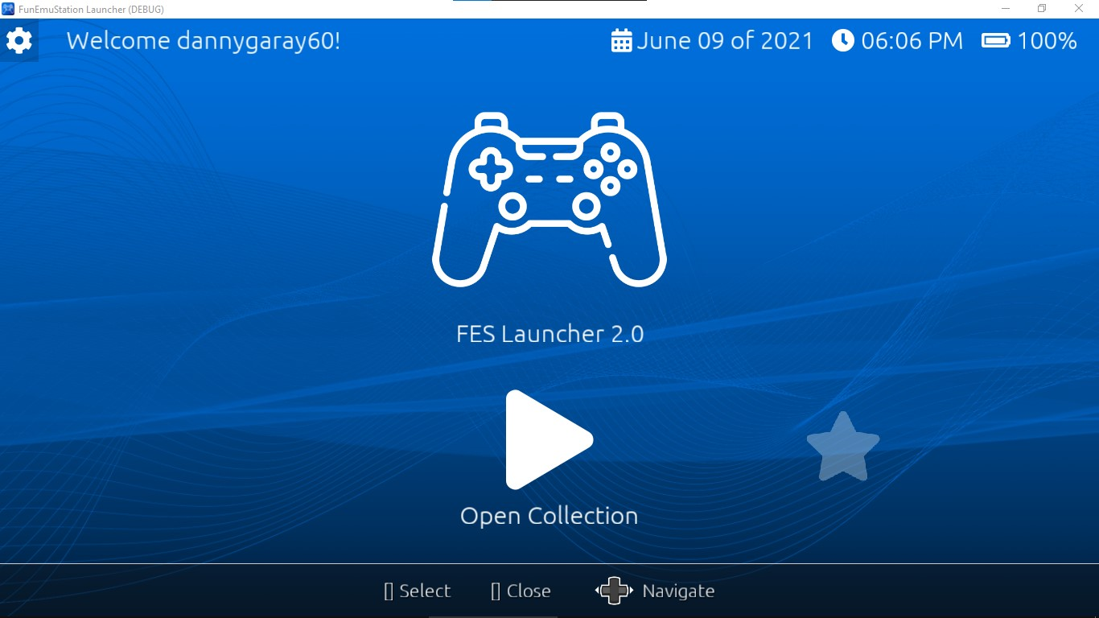

You will first need to configure the controls by clicking on the gear icon button at the top left.

This is the main configuration screen:

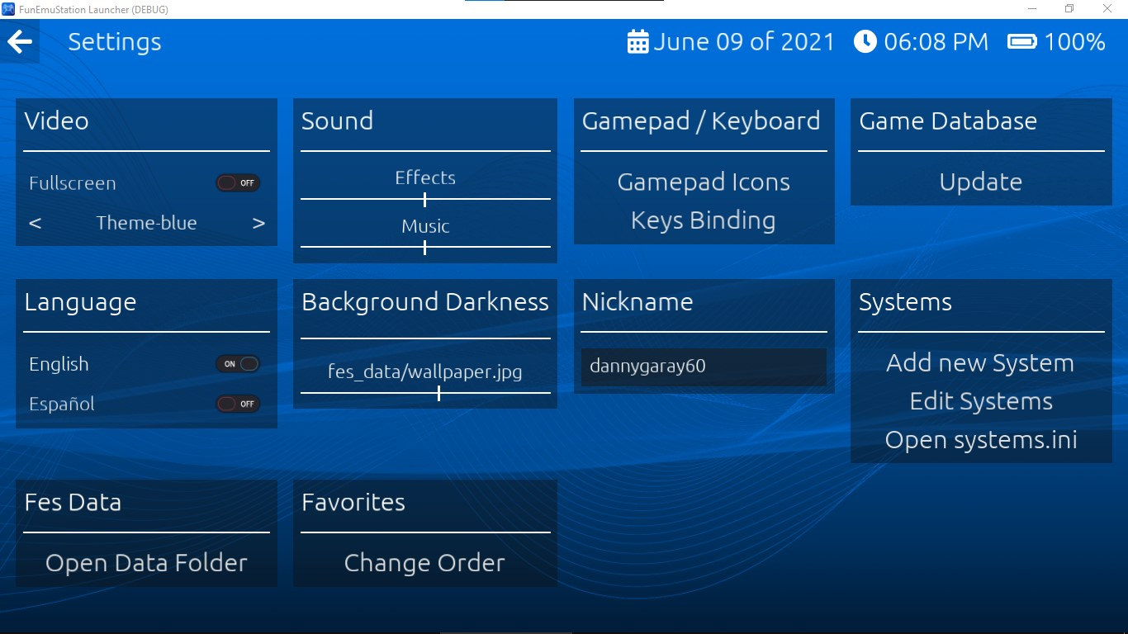

Click on the "Controls remapping / Keys binding" button. And in the next screen select use keyboard or gamepad. And then click on the button you want to change and then press the new key for the action.

Note: If your gamepad buttons do not respond, try adding a custom gamepad mapping, you can use the **SDL2 Gamepad Tool** [(](https://generalarcade.com/gamepadtool/)**https://generalarcade.com/gamepadtool/)** to generate a mapping string and paste it into the text box, then press "apply" and the buttons should work (this problem is more common on generic gamepads).

When using gamepad you can also use a "combo" action which is a combination of 4 buttons to close any emulated game in the launcher directly from the gamepad, for example, press L1 + R1 + L2 + R2 + R2. (If you want to use only two buttons, simply add the button twice (R1 + R1 + L1 + L1 + L1).

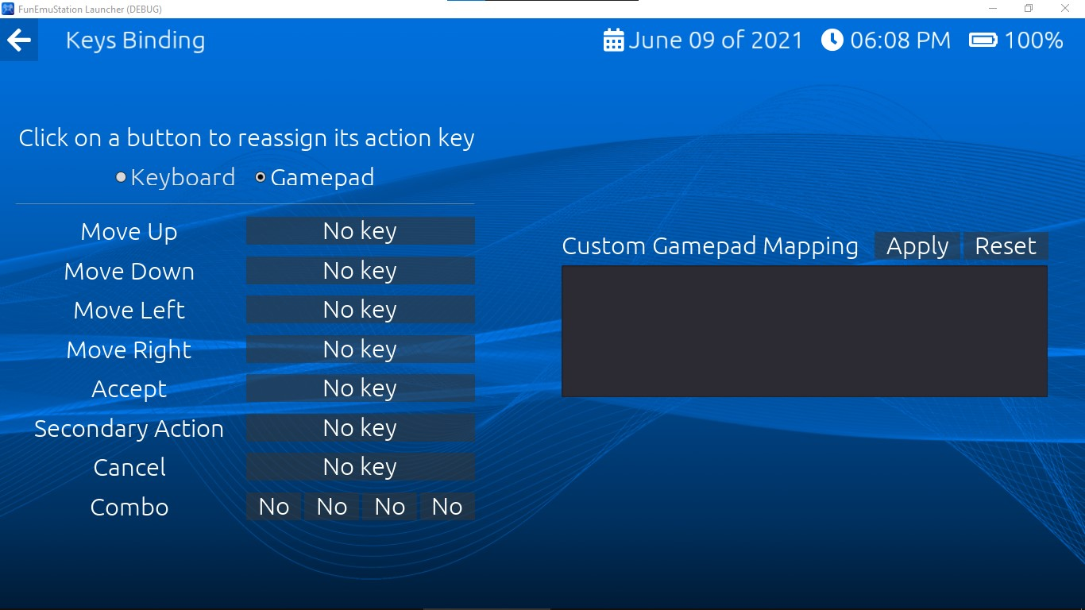

Depending on whether you are using a keyboard or gamepad, the button icons will change:

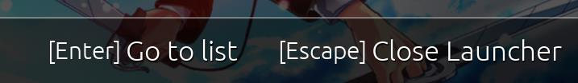 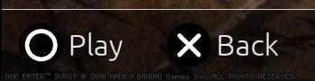

You can change the icons of the gamepad buttons from the main options menu.

# Adding an emulation system

Go to the main options screen and click on "Add new system" and you will see the following screen:

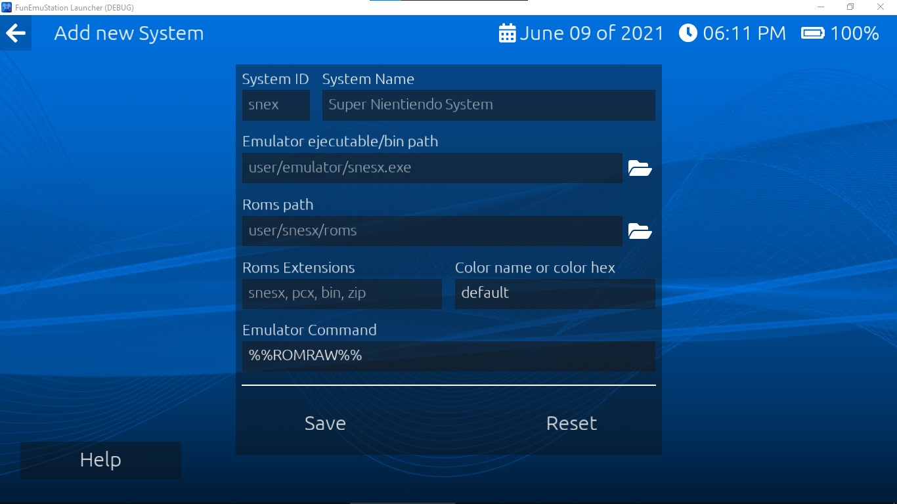

Simply fill in the requested data. If you do not know exactly what you should type, press the help button at the bottom left which will show you all the commands and data you should enter.

**Note: Any changes to the system configuration, change of paths or files, you must perform a scan of the launcher database from the main options screen to apply these changes.**

# Mac (Apple computers) and GNU/Linux support

Although there are executable versions for these systems, I am only providing technical support for Windows system users.

# Set custom cover art and backgrounds for each game

If you have done everything right in the previous steps, you will be able to use the launcher, but you can also place covers and backgrounds that change depending on the chosen game. Go to your roms folder and in that same folder place a jpg file with the same name as the rom, and optionally you can put another jpg file that will also carry the name of the rom, but at the end it will end with the text "_bg". See this example for reference:

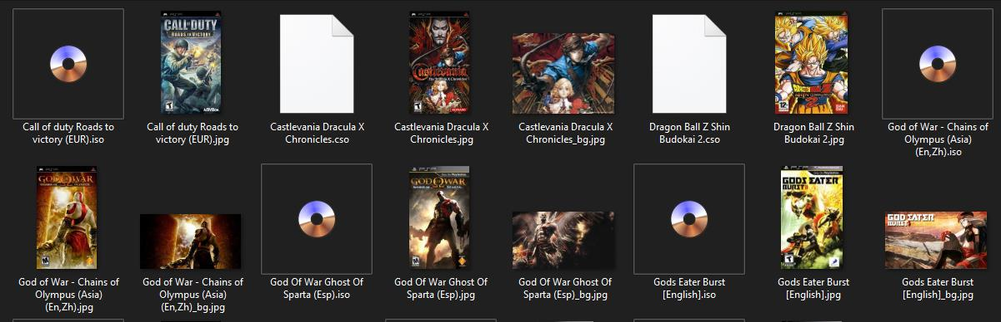

Note: You can use horizontal or vertical covers, but the latter is recommended for a better presentation. (The recommended resolution is 540 x 720 px)

Note2: If you want the background to fit perfectly in the launcher, use an image with dimension 1366 x 768 px.

Note3: If you want to download retro game covers or wallpapers, check "Links of interest" in the main menu.

Note4: As of version 1.3 the image files (covers, backgrounds) must be placed in a folder called "media" which must be located in the same folder as roms.

# Start-up

After all the above mentioned steps, you can start playing, depending on the size of the cover and background images, the navigation between games may be slightly slow.

When running a rom, you will see the following screen:

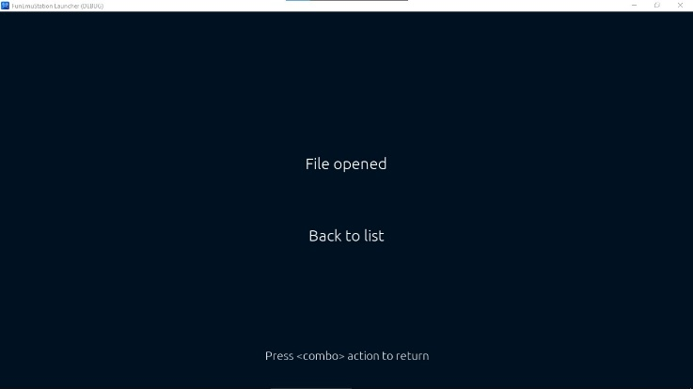 In this screen you can use the "combo" action to close the emulated game and return to the game list.

# Additional Configuration

You can also set an image as the main background for the launcher. Simply add an image called "wallpaper" in jpg format to the "fes_data" folder. The darkness of the background images can be changed in the main options screen.

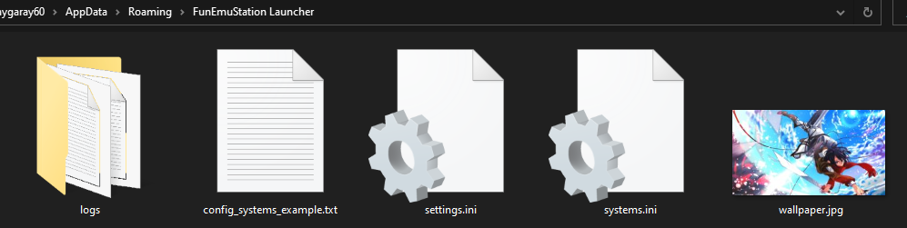

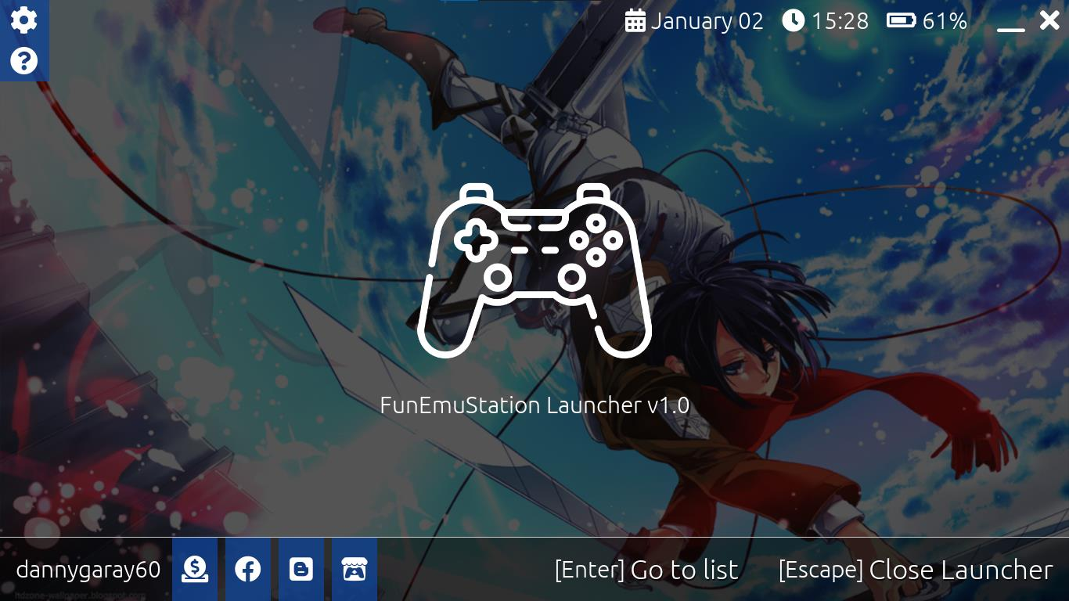

With the secondary action button you can add and remove games from the favorites list and change the order of the list from the options screen.

If you want to change the order in which the emulation systems appear, you must modify the fes_data/systems.ini file manually and move the configuration blocks to the desired order.

With all of the above FES Launcher should already be running smoothly. Note that (with the exception of the configuration screens) FES Launcher is designed to be used with a keyboard or gamepad.

# Known Issues

**When closing an emulator from the keyboard, the screen turns black or the launcher does not work properly:** Disable full screen, this should not give problems if you close the emulator with the combo action.

**The selected game does not start:** There can be different reasons; There is some error in the command defined in systems.ini or the game name contains a comma. You can see the list of errors in **AppData/Roaming/FunEmuStation Launcher/logs/godot.log** (on Windows systems).

**I can't close a native pc game using the gamepad combo combination:** The combo action will only work with roms run from emulator.

**Sometimes it takes too long to open an emulator:** Loading times depend on the emulator to be run, I can't do more about it.

**Dolphin emulator does not start with an SD memory inserted:** Dolphin emulator in FES Launcher will create a folder called "User" in the same folder of the launcher, there you must place the memory files.

**The list of roms is not displayed correctly or the emulator does not start:** Possibly there is an error in the systems.ini file You should also make sure that the roms folder is not empty.

**My problem is not listed:** Hire technical support at itch.io and I will be happy to help you, if you think it is a bug, please report it in the [github repository.](https://github.com/dannygaray60/funemustation)

**Note:** To reset the launcher to its initial configuration, delete all files in the launcher data folder and restart it.

# Links of Interest

Technical support or download the configuration tool

<https://dannygaray60.itch.io/funemustation-launcher>

Developer's games

<https://dannygaray60.itch.io/>

Discord

<https://discord.gg/jkCVcf2vwH>

FES Launcher source code

<https://github.com/dannygaray60/funemustation>

Contact

dannygaray60@gmail.com